Practical 9

Name: Tushar Harsora

Roll Number: 19BCE509

# Introduction

In this practical we are going to generate the machine code for the input source code. The output code can be any type like 3 address code, stack machine etc. in this practical I implemented Enums and structures for different node types in syntax tree. And parse through the syntax tree. The lexer currently only supports while loop and if else statements. Assignment, arithmetic operations are supported. The required code is attached in zip file with script to build executable.

# Screenshots

Below example demonstrates the basic arithmetic operation and corresponding code generated.

# 

This example is also expression but it includes the variables and output code also uses variables.

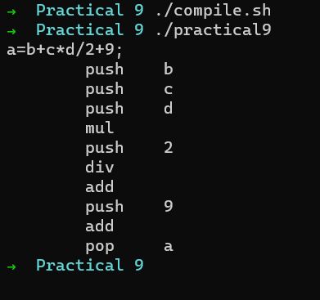

This example uses the while loop with the variable. We can see that the labels are generated in sequential manner and first component in loop is entry condition check. Then jump to exit of loop. After entry condition the body of loop is there and after body code unconditionally jumps to beginning of loop.

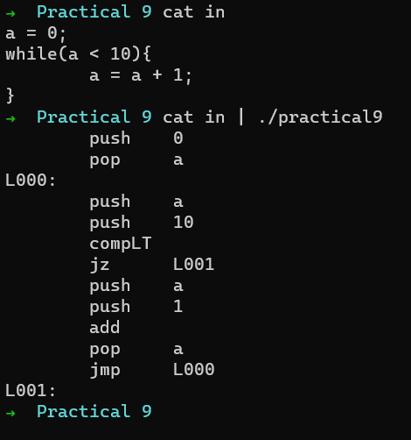

In example given below we are using while with nested if condition and the corresponding output generated is correct even in this case.

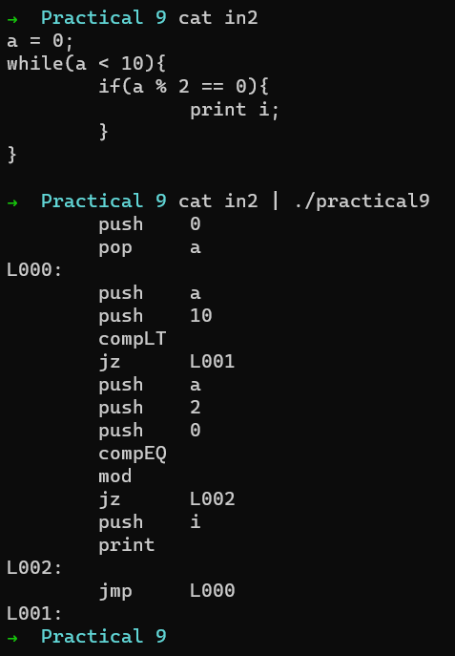

# Conclusion

In this practical we studied how code generation works and what are different type of address codes. What type of code compiler should generate for ex. Intermediate code, machine code, virtual machine code, etc. what are advantages and disadvantages of each of these methods. And how source code is mapped to various compiler constructs and how to convert into assembly.